How to make read.me file

<https://docs.github.com/en/account-and-profile/setting-up-and-managing-your-github-profile/customizing-your-profile/managing-your-profile-readme>

Shiny server document

<https://docs.rstudio.com/shiny-server/>

Shiny server prerequisite

$ sudo apt-get install r-base

$ sudo apt-get install gdebi-core

$ sudo gdebi shiny-server-<version>.deb

Shiny server start/end/restart

$ sudo systemctl start shiny-server

$ sudo systemctl stop shiny-server

$ sudo systemctl restart shiny-server

Default configuration file

/etc/shiny-server/shiny-server.conf

Basic port number : listen 3838;

Basic site directory : site_dir /srv/shiny-server;

Basic site directory : log_dir /var/log/shiny-server;

Test at the R studio env

Manual kr/en

kr/ ppt

En/ read me

Shiny manual

Port Number :3838

Portal main

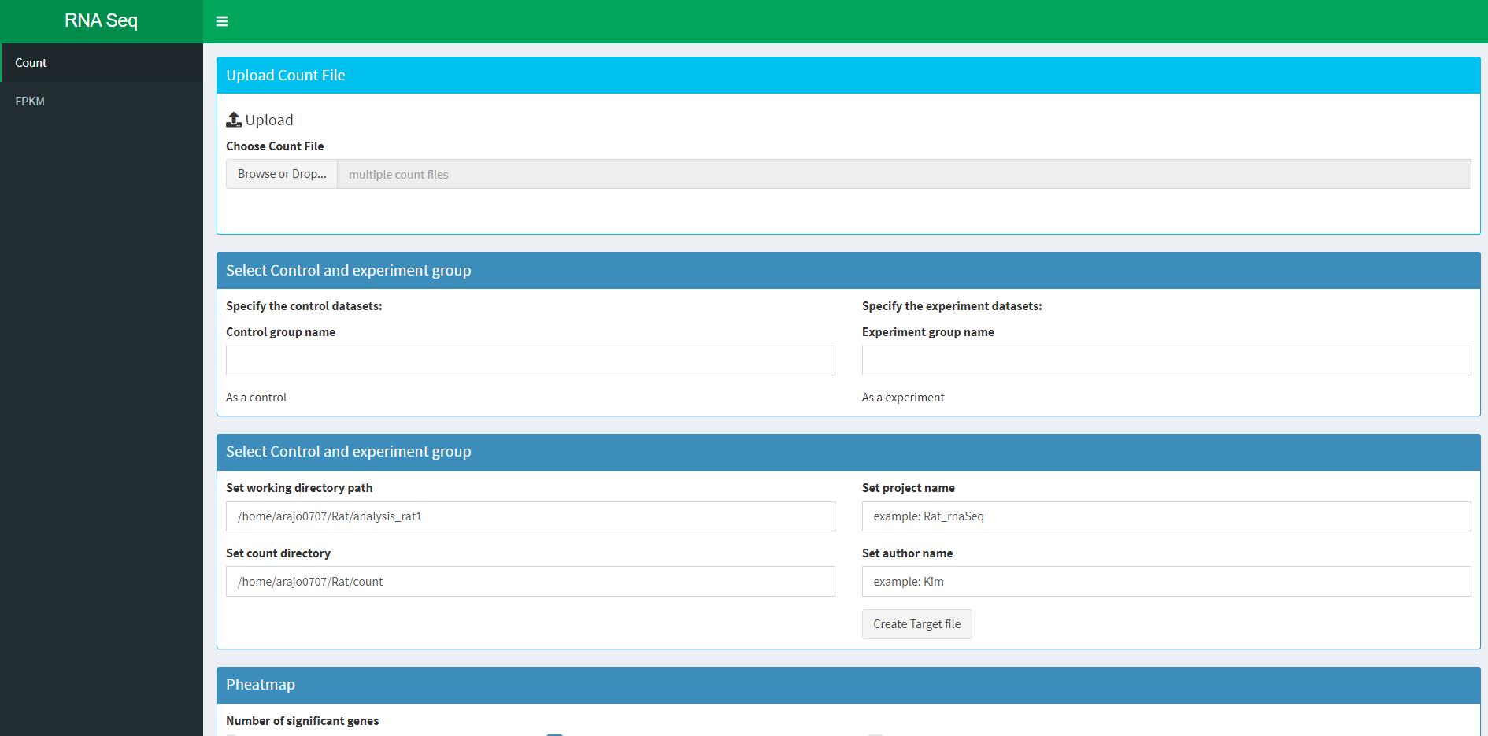

Program description

This program allows the user to create a target file by choosing the .count files through GUI.

All the files needed for this program can be generated /home/arajo0707/Rat/{Sample name}.sh Count files are generated at the directory named same with the sample name. FPKM files are produced in the directory names fpkm. This program uses “rnorvegicus_gene_ensembl” of the Ensembl database for gene expression analysing using EdgeR package.

1. Upload count file

Click Browse or Drop

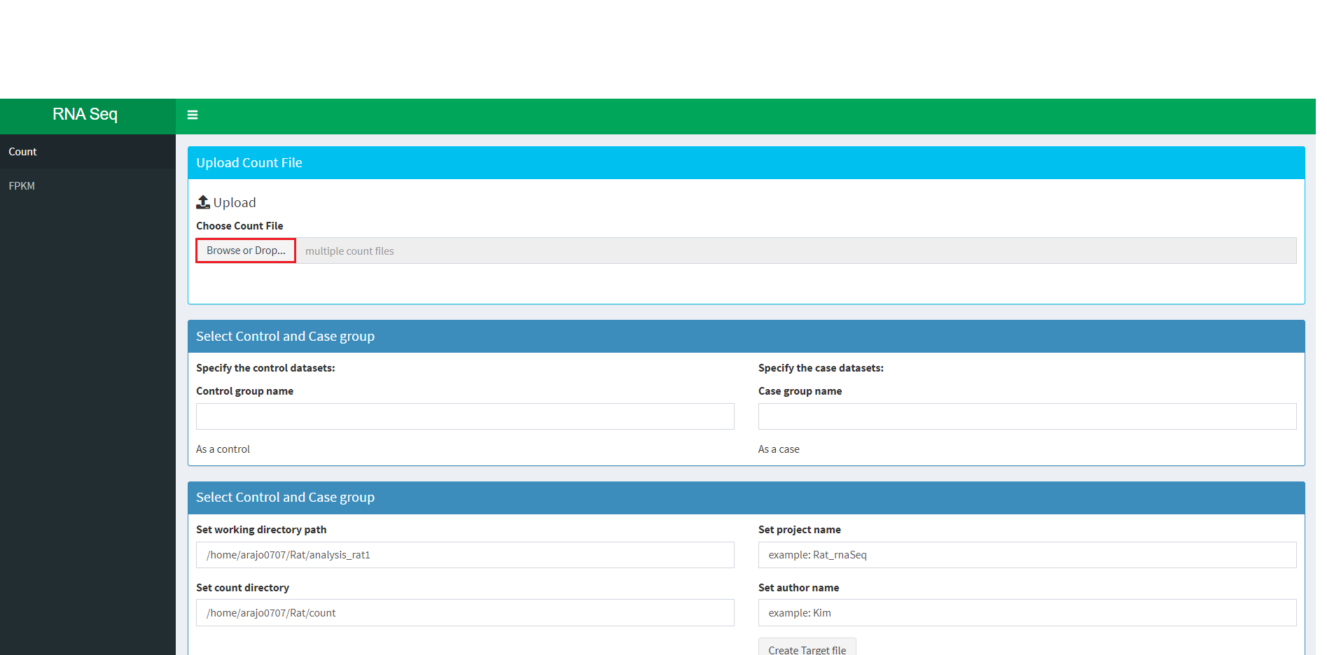

Select multiple .count files

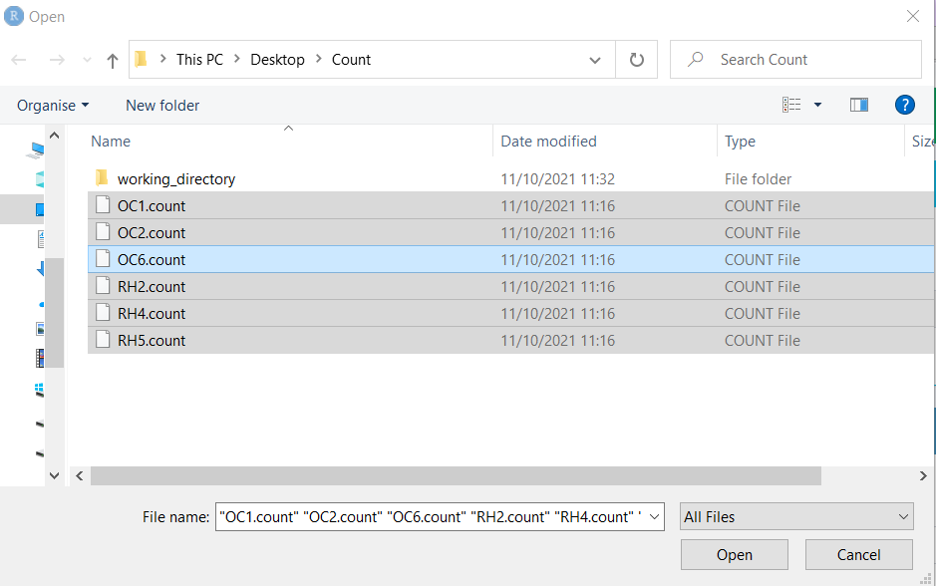

1. Select Case and Control group sample and group name

Select control group and case group and type the group name for the case and control.

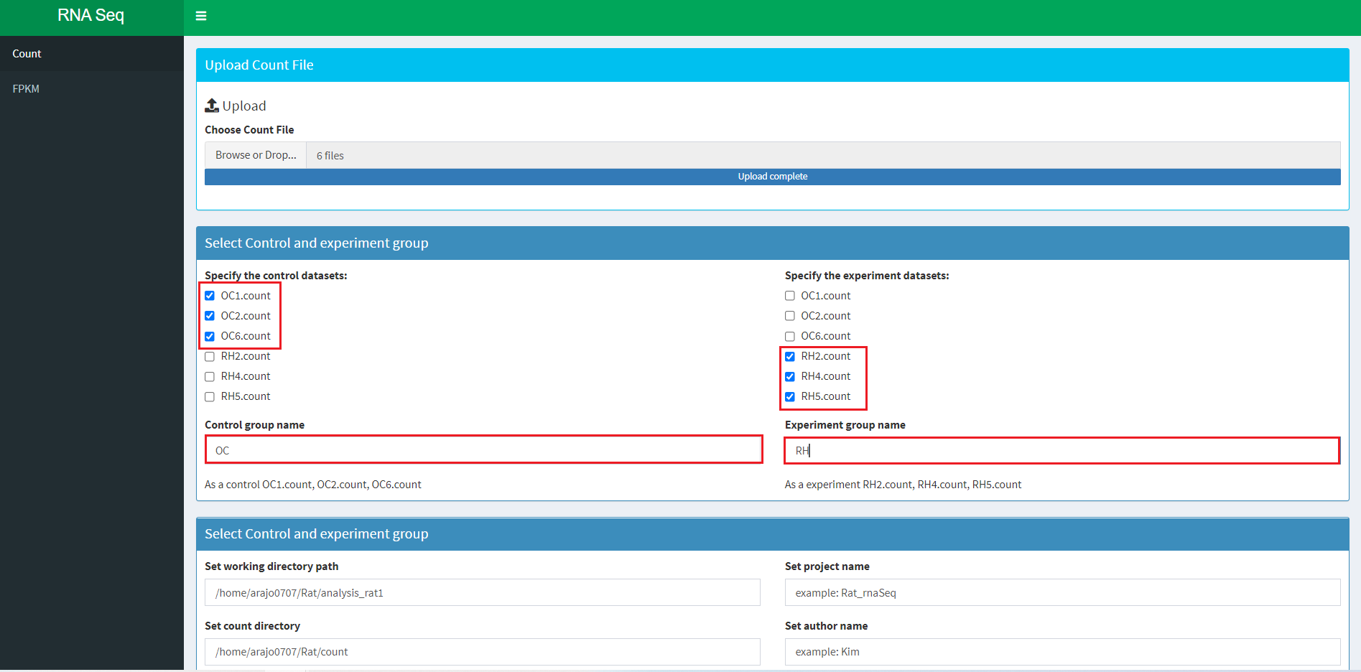

Set the working directory path, count file directory, project name and author.

(Both directory paths should not end with ‘/’. The working directory requires ‘figures’, ’EdgeR’, ’tables’ subdirectories.)

Then click the Create Target file button.

It will create the target file at the working directory and automatically load all .count files that you have selected.

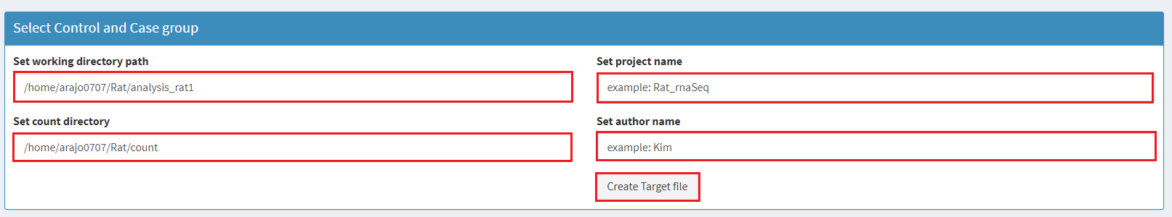

1. Heatmap

Once the files have been uploaded, the program will analyse the data and select genes with the highest 35 gene expression. The default value of the gene expression is 20. You can drag the slider to see the different number of genes. It will take several minutes to calculate the gene expressions and plot the heatmap.

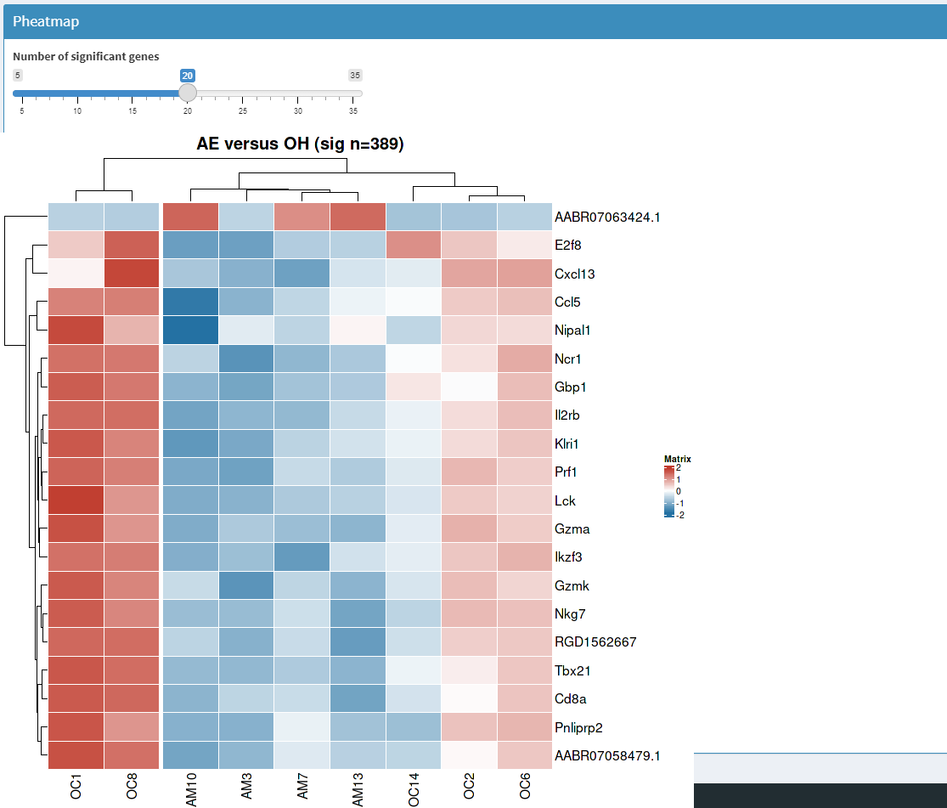

1. Plots

Necessary plots(dense plot, box plot, volcano plot) are also on the Plot box. Detailed and high quality plots can be found in {Path-to-working-directory}/figure.

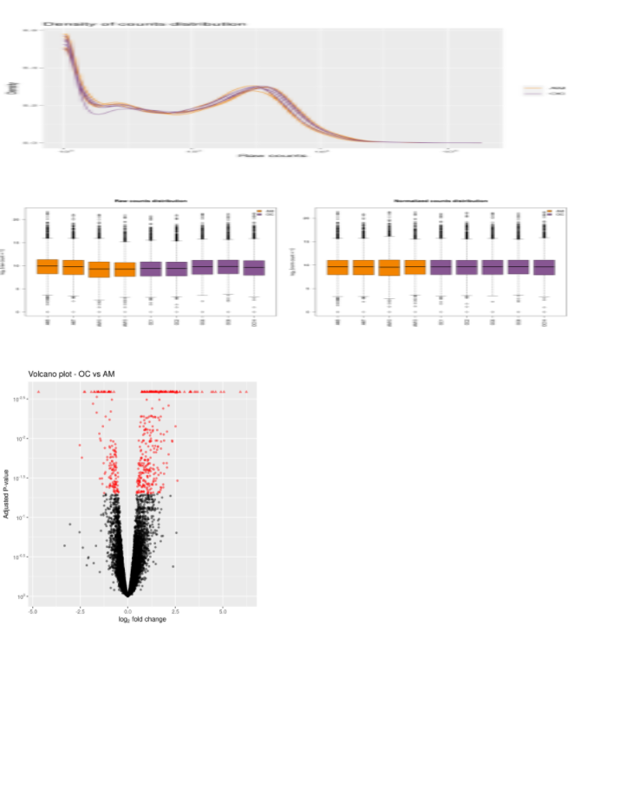

1. FPKM heatmap

To get a FPKM heatmap you need fpkm input files. All fpkm files should be in the fpkm directory path. Then press Create fpkm heatmap button to generate the fpkm heatmap. It will take several minutes to plot the heatmap.

